**My Company**

***Process Definition Document***

Processing Patient Data

Downloading the daily appointment list from the health care portal, identifying the care type, and updating the priority information in the extended private care subscriptions accordingly.

# Table of Contents

As-Is process description 2

1. Process Overview 2

2. As-Is Process map 2

3. Process statistics 3

4. Detailed As-Is Process Actions 4

# As-Is process description

## 1. Process Overview

General information about the process selected for RPA prior to automation.

|  |  |  |
| --- | --- | --- |
| **#** | **Item** | **Description** |
| 1 | **Process full name** | Processing Patient Data |
| 2 | **Process short description (operation, activity, outcome)** | Downloading the daily appointment list from the health care portal, identifying the care type, and updating the priority information in the extended private care subscriptions accordingly. |
| 3 | **Process execution time** | 1 min. 34 sec. |

## 2. As-Is Process map

### High Level As-Is Process Map:

This chapter depicts the As-Is business process at a High Level to enable developers to have a high-level understanding of the current process.

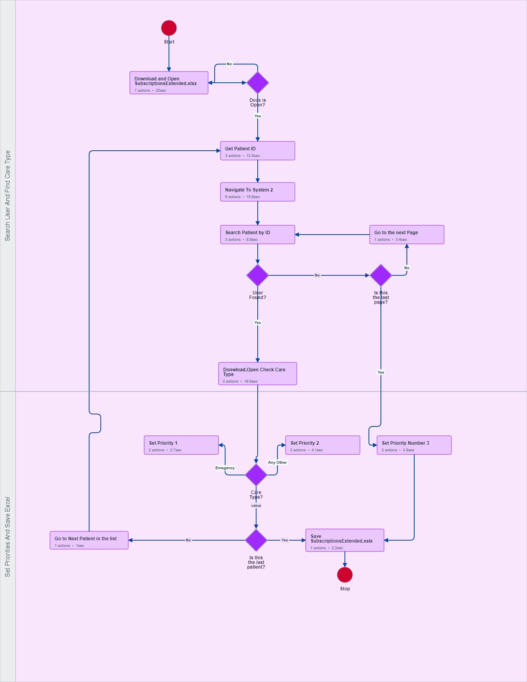

## 3. Process statistics

### Detailed statistics

|  |  |  |  |
| --- | --- | --- | --- |
| Window name | Mouse Clicks | Text entries | Keys pressed |
| New tab - Personal - Microsoft​ Edge | 2 | 0 | 8 |
| 8LJS7ahB_1IjCby4_eHcktG85b9GJhykE-SubscriptionsExtended.xlsx and 1 more page - Personal - Microsoft​ Edge | 1 | 0 | 0 |
|  | 4 | 0 | 8 |
| Save As | 1 | 0 | 0 |
| Google - Personal - Microsoft​ Edge | 1 | 0 | 8 |
| ACME System 1 - Dashboard - Personal - Microsoft​ Edge | 2 | 0 | 0 |
| ACME System 1 - Medical - Personal - Microsoft​ Edge | 3 | 0 | 0 |
| 56062-008_appointment.xlsx and 1 more page - Personal - Microsoft​ Edge | 1 | 0 | 0 |
| ACME System 1 - Medical and 1 more page - Personal - Microsoft​ Edge | 1 | 0 | 0 |
| Practice 2 | 1 | 0 | 0 |
| SubscriptionsExtended.xlsx [Protected View] - Excel | 1 | 0 | 0 |
| SubscriptionsExtended.xlsx - Excel | 10 | 0 | 3 |
|  | 1 | 0 | 0 |

## 4. Detailed As-Is Process Actions

#### Download and Open SubscriptionsExtended.xlsx

|  |  |
| --- | --- |
|  | **Est. time: 20.0 sec.** |

##### Open Searchbar

|  |  |
| --- | --- |
| Click on the searchbar | **Est. time: 1.10 sec.** |
| image | Action: Click |

##### Paste link

|  |  |
| --- | --- |
| Onsert the link to:https://acme-test.uipath.com/reboot-your-skills | **Est. time: 1.9 sec.** |
| image | Action: Click |

##### Click download

|  |  |
| --- | --- |
| Click to download the appointment file | **Est. time: 8.5 sec.** |
| image | Action: Click |

##### Click on save

|  |  |
| --- | --- |
| Click on save to save locally | **Est. time: 1.3 sec.** |
| image | Action: Click |

##### Rename the file

|  |  |
| --- | --- |
| Give the file a simple name | **Est. time: 3.1 sec.** |
| image | Action: Click |

##### Double click on the file

|  |  |
| --- | --- |
| Double click to open the excel file. | **Est. time: 2.1 sec.** |
| image | Action: Double Click |

##### Result

|  |  |
| --- | --- |
| The open excel file. | **Est. time: 1.0 sec.** |
| image | Action: Double Click |

#### Docs is Open?

|  |  |
| --- | --- |
| If 'No' then go to '1. Download and Open SubscriptionsExtended.xlsx'  If 'Yes' then go to '3. Get Patient ID' | **Est. time: 0.0 sec.** |

#### Get Patient ID

|  |  |
| --- | --- |
|  | **Est. time: 12.8 sec.** |

##### Select patient ID

|  |  |
| --- | --- |
| Select the PatientID cell | **Est. time: 1.1 sec.** |
| image | Action: Double Click |

##### Right Click

|  |  |
| --- | --- |
| Right Click on the cell data | **Est. time: 9.8 sec.** |
| image | Action: Click |

##### Copy

|  |  |
| --- | --- |
| Select copy option from context menu | **Est. time: 1.9 sec.** |
| image | Action: Click |

#### Navigate To System 2

|  |  |
| --- | --- |
|  | **Est. time: 15.9 sec.** |

##### Go to System 2

|  |  |
| --- | --- |
| Click search bar and pate CTRL-V :https://acme-test.uipath.com/reboot-your-skills | **Est. time: 4.5 sec.** |
| image | Action: Click |

##### Open Health Care Options

|  |  |
| --- | --- |
| Click or Hover on 'Health Care' button | **Est. time: 4.4 sec.** |
| image | Action: Click |

##### Select first option from dropdown

|  |  |
| --- | --- |
| Click 'Download Daily Appointment' | **Est. time: 2.8 sec.** |
| image | Action: Click |

##### Open options for Day

|  |  |
| --- | --- |
| Click on the Day dropdown | **Est. time: 1.9 sec.** |
| image | Action: Click |

##### Choose Today

|  |  |
| --- | --- |
| Click on 'Today' | **Est. time: 2.4 sec.** |
| image | Action: Click |

#### Search Patient by ID

|  |  |
| --- | --- |
|  | **Est. time: 8.9 sec.** |

##### Open Page Search Bar

|  |  |
| --- | --- |
| Press 'CTRL+F' to open | **Est. time: 2.8 sec.** |
| image | Action: Click |

##### Enter PatientId to Saerch

|  |  |
| --- | --- |
| Press 'CTRL V' | **Est. time: 2.8 sec.** |
| image | Action: Click |

##### Submit the search

|  |  |
| --- | --- |
| Press 'Enter' | **Est. time: 3.4 sec.** |
| image | Action: Click |

#### User Found?

|  |  |
| --- | --- |
| If 'Yes' then go to '7. Donwload,Open Check Care Type'  If 'No' then go to '13. Is this the last page?' | **Est. time: 0.0 sec.** |

#### Donwload,Open Check Care Type

|  |  |
| --- | --- |
|  | **Est. time: 19.8 sec.** |

##### Open Appointment File

|  |  |
| --- | --- |
| Click on the file link | **Est. time: 4.9 sec.** |
| image | Action: Click |

##### Check the Care Type

|  |  |
| --- | --- |
| Highlight the care type | **Est. time: 14.9 sec.** |
| image | Action: Click |

#### Care Type?

|  |  |
| --- | --- |
| If 'value' then go to '9. Is this the last patient?'  If 'Any Other' then go to '11. Set Priority 2'  If 'Emegency' then go to '12. Set Priority 1' | **Est. time: 0.0 sec.** |

#### Is this the last patient?

|  |  |
| --- | --- |
| If 'No' then go to '10. Go to Next Patient in the list'  If 'Yes' then go to '16. Save SubscriptionsExtended.xslx' | **Est. time: 0.0 sec.** |

#### Go to Next Patient in the list

|  |  |
| --- | --- |
|  | **Est. time: 1.0 sec.** |

##### Go to next patient

|  |  |
| --- | --- |
| Select the next user Patent on the list | **Est. time: 1.0 sec.** |
| image | Action: Click |

##### Go to: Save SubscriptionsExtended.xslx

|  |  |
| --- | --- |
|  | **Est. time: 0.0 sec.** |
|  | Action: NONE |

#### Set Priority 2

|  |  |
| --- | --- |
|  | **Est. time: 4.1 sec.** |

##### Select Priority cell

|  |  |
| --- | --- |
| Click on the on the cell that you want to insert data in. | **Est. time: 2.7 sec.** |
| image | Action: Double Click |

##### Paste Data

|  |  |
| --- | --- |
| Type in 2 | **Est. time: 1.4 sec.** |
| image | Action: Click |

#### Set Priority 1

|  |  |
| --- | --- |
|  | **Est. time: 2.7 sec.** |

##### Select the priority cell

|  |  |
| --- | --- |
| Click on the on the cell that you want to insert data in. | **Est. time: 1.7 sec.** |
| image | Action: Double Click |

##### Set Priorty of 1

|  |  |
| --- | --- |
| type in 1 | **Est. time: 0.10 sec.** |
| image | Action: Click |

#### Is this the last page?

|  |  |
| --- | --- |
| If 'No' then go to '14. Go to the next Page'  If 'Yes' then go to '15. Set Priority Number 3' | **Est. time: 0.0 sec.** |

#### Go to the next Page

|  |  |
| --- | --- |
|  | **Est. time: 3.4 sec.** |

##### Go to next page

|  |  |
| --- | --- |
| Click on the 'Right Arrow' | **Est. time: 3.4 sec.** |
| image | Action: Click |

##### Go to: Search Patient by ID

|  |  |
| --- | --- |
|  | **Est. time: 0.0 sec.** |
|  | Action: NONE |

#### Set Priority Number 3

|  |  |
| --- | --- |
|  | **Est. time: 3.8 sec.** |

##### Click t Priority cell

|  |  |
| --- | --- |
| Click on the on the cell that you want to insert data in. | **Est. time: 1.5 sec.** |
| image | Action: Double Click |

|  |  |
| --- | --- |
|  | **Est. time: 2.3 sec.** |
| image | Action: Click |

#### Save SubscriptionsExtended.xslx

|  |  |
| --- | --- |
|  | **Est. time: 2.2 sec.** |

##### Save Excel File

|  |  |
| --- | --- |
| Click on save at the top left Corner | **Est. time: 2.2 sec.** |
| image | Action: Click |

#### Stop

|  |  |
| --- | --- |
|  | **Est. time: 0.0 sec.** |